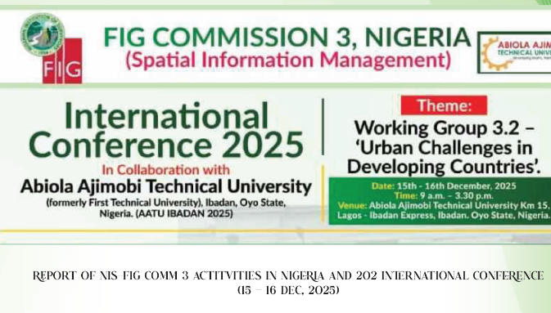
Links to papers

NIS-FIG Commission 3 Work Group - International Conference 2025
Nigeria

Guest speaker Lecture
Femi Akintola
Harnessing Geospatial Technologies to Address Multi-Facet Urban Challenges in Developing Countries with Special Focus on Nigeria
https://www.fig.net/organisation/comm/3/news/2025-nis-wg-c3/1b_paper_F_Akintola_FIG_C3_dec25.pdf

Lecture 1
Funmilola Helen Fakorede
Urban Challenges in Developing Countries: Through the Female Professional Surveyor’s Lens
https://www.fig.net/organisation/comm/3/news/2025-nis-wg-c3/2_paper_FH_Fakorede_FIG_C3_dec25.pdf

Lecture 2
Olumide Vincent Adewebi
Urban Challenges in Developing Countries: A Professional Perspective
https://www.fig.net/organisation/comm/3/news/2025-nis-wg-c3/3_paper_OV_Adewebi_FIG_C3_dec25.pdf

Lecture 3
David Elegbede
Urban Challenges in Developing Countries: Young Professional Perspective
https://www.fig.net/organisation/comm/3/news/2025-nis-wg-c3/4_ppt_D_Elegbede_FIG_C3_dec25.pdf

P 101
Adesola Adediran, Clementina A. Olaoye, Ibrahim R. Olatunji & Abubakar Azeez
Geospatial Analysis of Water Supply Sources in selected Rural Communities of Oyo State
https://www.fig.net/organisation/comm/3/news/2025-nis-wg-c3/5_paper_A_Adediran_et_al_FIG_C3_dec25.pdf

P 102
Ayoola Akinbiola, Abimbola Theophilus Alabi, Adedayo Tolulope Adeboye & Ayomide Emmanuel Olubaju
Assessment of Land Cover Changes in Igbojaye Mining Community, Ibadan, Oyo State
https://www.fig.net/organisation/comm/3/news/2025-nis-wg-c3/6_paper_SE_Akinbiola_et_al_FIG_C3_dec25.pdf

P 103
Ibrahim Olatunji Raufu
Two Decades of Land Surface Temperature Response to Land Cover Change in Ikorodu, Nigeria: A Remote Sensing Analysis (2002-2022)
https://www.fig.net/organisation/comm/3/news/2025-nis-wg-c3/7_paper_IO_Raufu_FIG_C3_dec25.pdf

P 104
Tobi Olatokunbo Sowole
Geospatial Intelligence for Crime Prevention: An Applied Framework for Predictive Policing and Urban Security Planning in Nigeria
https://www.fig.net/organisation/comm/3/news/2025-nis-wg-c3/8_ppt_TO_Sowole_FIG_C3_dec25.pdf

P 105
O. P. Aikomo
Roles of Surveying Professionals in Public Education on Land Matters
https://www.fig.net/organisation/comm/3/news/2025-nis-wg-c3/9_paper_OP_Aikomo_FIG_C3_dec25.pdf

P 106
Dahunsi Julianah Olamide, Peter Oyelere, Adeboye Adedayo Tolulope, Adedeji Tolulope Mary & Aworinde Ronke Felicia1
Spatial Dynamics of Roadside Trading in Ibadan Metropolis: A GIS Approach to Market Organization and Urban Planning
https://www.fig.net/organisation/comm/3/news/2025-nis-wg-c3/10_paper_DJ_Olamide_et_al_FIG_C3_dec25.pdf

P 201
A. T. Alabi1, F. O. Adigun, D. D. Olatide, S. A. Akinbiola & T. M. Adedeji
Jurisdictional Imbalance in Land Administration: Penumbras within the Land Use Act
https://www.fig.net/organisation/comm/3/news/2025-nis-wg-c3/11_paper_AT_Alabi_et_al_FIG_C3_dec25.pdf

P 202
Tata Herbert, Elufisan Paul Tomilola, Nnamani Onyemaechi John and Olatunbosun Victor Ayoola
Geospatial Evaluation of the Impact of Noise Pollution on Public Health in Osogbo's Central Business District, Osun State, Nigeria
https://www.fig.net/organisation/comm/3/news/2025-nis-wg-c3/12_paper_T_Herbert_et_al_FIG_C3_dec25.pdf

P 203
Micheal Jomiloju Oyediran, Ayomide Emmanuel Olubaju, Sehinde Ayoola Akinbiola, & Adedayo Tolulope Adeboye
Temporal Socio-Spatial Implications and Urban Planning Dimensions of Flooding Using Google Earth Engine (GEE): A Case Study of Lagos State
https://www.fig.net/organisation/comm/3/news/2025-nis-wg-c3/13_paper_MJ_Oyediran_et_al_FIG_C3_dec25.pdf

P 204
S. Chukwu & E. A. Adesina
Forecasting Urban Flood Risk in Dam-Regulated Catchments: A Dynamic Ann Framework Integrating Urban Growth and Climate Scenarios
https://www.fig.net/organisation/comm/3/news/2025-nis-wg-c3/14_ppt_S_Chukwu_et_al_FIG_C3_dec25.pdf

P 205
Ayomide E. Olubaju, Sehinde A. Akinbiola, Abimbola T. Alabi, Johnson A. Ibukun, Favour S. Thomas & Micheal J. Oyediran
Geospatial Assessment of Mining-Induced Environmental Degredation and Community Exposure in Ife-Ilesha-Osogbo Axis, Osun State, Nigeria
https://www.fig.net/organisation/comm/3/news/2025-nis-wg-c3/15_paper_AE_Olubaju_et_al_FIG_C3_dec25.pdf

P 206
Maleek Opeyemi Tijani, Akinbiola Sehinde, Emmanuel Olubaju & Adedayo Adeboye
Assessment of Coastal Land Cover Change and Integrated Flood Vulnerability Modeling in Lagos Lagoon, Nigeria (2015–2025)
https://www.fig.net/organisation/comm/3/news/2025-nis-wg-c3/16_paper_MO_Tijani_et_al_FIG_C3_dec25.pdf

P 207
Tata Herbert, Akinde, Rebecca Idowu & Sehinde Ayoola Akinbiola
Spatiotemporal Analysis of Deforestation and Its Impact in Ago-Owu Forest Reserve: Predicting the Future of Forest Health
https://www.fig.net/organisation/comm/3/news/2025-nis-wg-c3/17_paper_T_Herbert_et_al_FIG_C3_dec25.pdf

P 208
Aneehat Okesade
Using Localized Spatial Information to Improve Urban Navigation
https://www.fig.net/organisation/comm/3/news/2025-nis-wg-c3/18_ppt_A_Okesade_FIG_C3_dec25.pdf

Conference report
https://www.fig.net/organisation/comm/3/news/2025-nis-wg-c3/1_report_FIG_C3-conf_dec25.pdf

